Patient Name: ………………………………………………………… Date of Birth: …………………………………………………………
Contact No…………………………………………………………………. Email: ………………………………………………………………….
Referral Doctor’s Name & Address: ………………………………………………………………………………………………………….
………………………………………………………………………………………………………………………………………………………………….
Endodontics Rayscan Digital Imaging (check of the following)
- Single (up to 4 adjacent sites) Area Specific: ……….……………………………………………………
- One Arch
- Two Arches
- TMJ Surgical Stent: Yes No
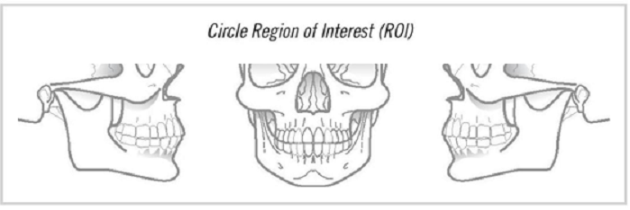
Service Desired: (check one of the following – referrals without check the following will auto default as option #2 – Full Set – See fee guide for fee references)

- Dicom Only (Taking Image + Interpretation Report + CD)
- Full Set (Includes Taking Image + Print out + Interpretation Report + CD)
- Full Set with Measurement (All of the above + Print out with measurements)
- Rush Case ($70 Fee will apply – 1 day turnaround time)
Special Instruction: ……………………………………………………………………………………………………………………..
…………………………………………………………………………………………………………………………………………………….
…………………………………………………………………………………………………………………………………………………….
…………………………………………………………………………………………………………………………………………………….
Referring Doctor’s Signature………………………………………………………….Date: …………………………………..
BROKEN APPOINTMENT FEE $75 (for less than 48 hrs notice)

